(Approx. 471 words)

Windows 10 Apps
By Rosita Herrick, Forum Leader, Sarasota Technology Users Group, Florida
March 2018 issue, STUGMonitor
www.thestug.org
rherrick (at) aol.com

Windows 10 was released officially almost 3 years ago, and most users upgraded directly from Windows 7, bypassing Windows 8 and 8.1. One of the new additions to the operating system are the Microsoft apps (short for applications). Apps are short programs that perform a specific task, are easy to install and uninstall and usually do not use many resources.

Apps are usually distributed with the operating system or can be downloaded from the Microsoft Store.

You can see all the programs available on your PC by displaying the All Programs option available on the start screen. Just click on the Windows Icon on the lower left corner of your monitor. If the list is not displayed, click on the All Apps icon

Here is a sample of the list when displayed:
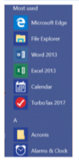
Personally, I just enter the name of the app in the Status bar search box
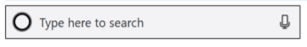
The apps I use quite a bit are as follows:

Money, Weather, News, Sports, Calculator, and Maps. They are easy to use and are fast. Here are common features of all the apps:

When clicking on the three lines icon, the title of each icon is displayed.

The search box on the right top enables you to search for relevant items; such as, a different city for the weather app, a specific sport team in the sport app or a company name or stock symbol.

When using the Maps app, the user can enter an address to see the map or click on the Directions icon to display the boxes for the starting point and the destination.

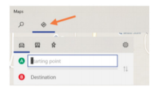
The Calculator app, in addition to the standard option, can be used to convert currency, temperature, area, speed, volume, etc. As in other apps, click on the menu icon to get different options.

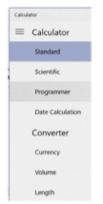
Here is an example of Length option to convert 100 Centimeters to Feet

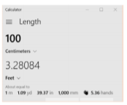
The best way to learn how to use the apps is to play with them and try different things. Also, the URL below has links to help for different apps.

https://support.microsoft.com/en-us/products/windows?os=windows-10

All the apps are available in the Microsoft Store. If you cannot find an app on your computer, click on the Store icon displayed on the Taskbar and type the name of the app in the search box.

For example, to find the News app, I typed News in the search box and here is the result:
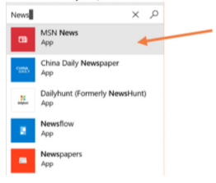

The Microsoft app will be on top as MSN News. Click on the link, and if it is already on you PC, you will get the following message:

If it is not on your PC, the message will look like this:

Click on the Get box and the app will be installed.

